Overview and Organization:

Welcome to the 997 / First Force field build day!

Make yourself a name tag. This is important for communication and safty.\*

Please check in with Eddie when you arrive and *please let Eddie know if you have to leave!*

This is what Eddie looks like: (By the end of the day, he looks like this:)

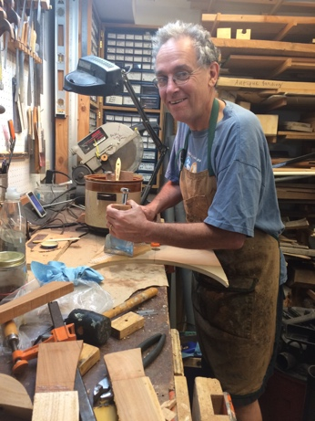 

All skill levels are welcome, but please let us teach you about saf\* machine use if you’re not an experienced woodworker. We’ll do our best to teach novices what they need to know, and please feel free to take an instruction packet.

We will take breaks every hour or so. Breaks are mandatory for safty\* reasons. You can’t work safly\* when you’re tired, hungry, thirsty or have a full bladder. I’ll flash the lights to announce a break – then I’ll cut the power off!

Leave snacks and drinks on this table or the classroom only. Put any extra clothes in the classroom.

Please don’t eat the pencils. (We’re always short on sharp pencils, so I’m pretty sure someone’s eating them.)

If you brought your own tools (thank you!), put them in the classroom. This really helps us keep track of which tools belong to the CHS shop.

Plug in battery chargers in the classroom – the shop does not have power when not in use.

\*Not a typo. It’s a 997 thing.